PROPERTY 1
Large 4 bedroom house available, all double rooms, 5 mins walk to campus. Large Garden.
Please contact Mrs Baker for more information on 07714313961 or 07740435312 or baker_karina@hotmail.com. Rental price to be confirmed.
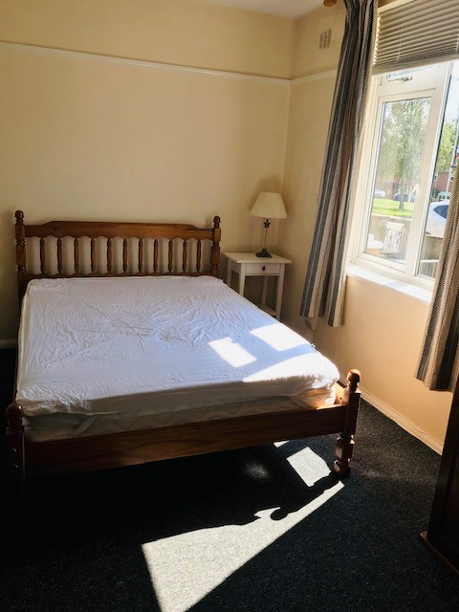
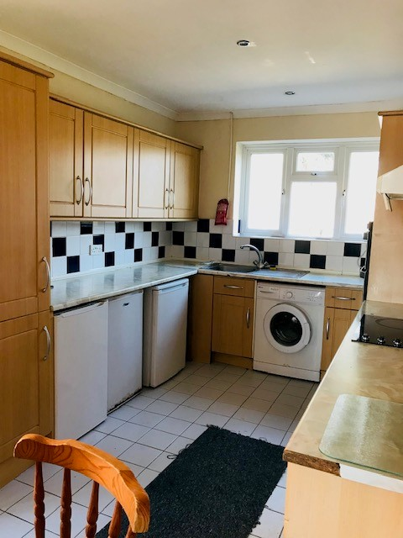

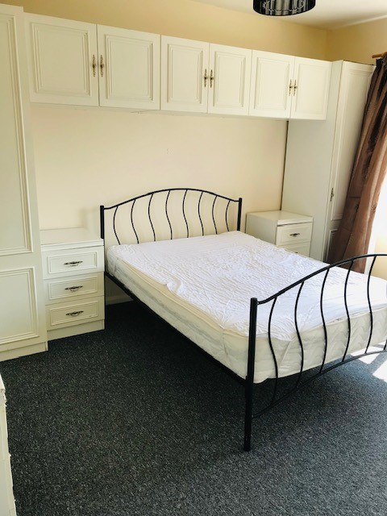
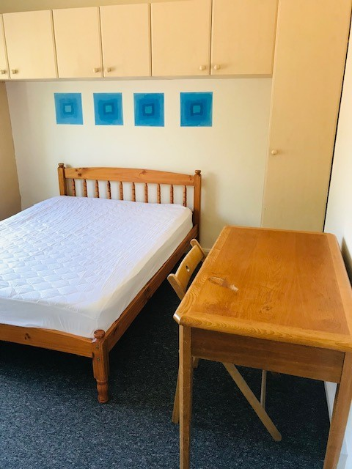

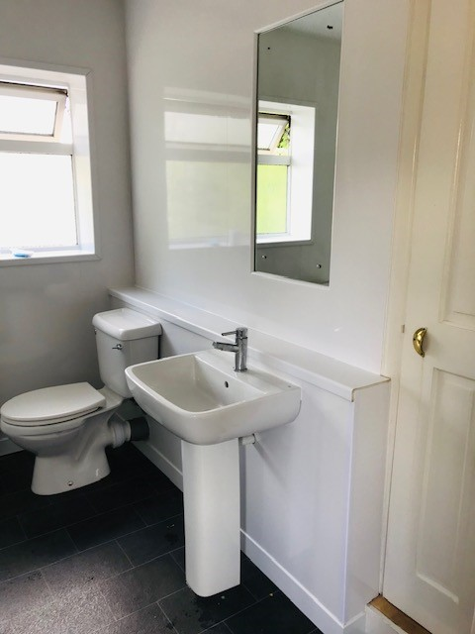
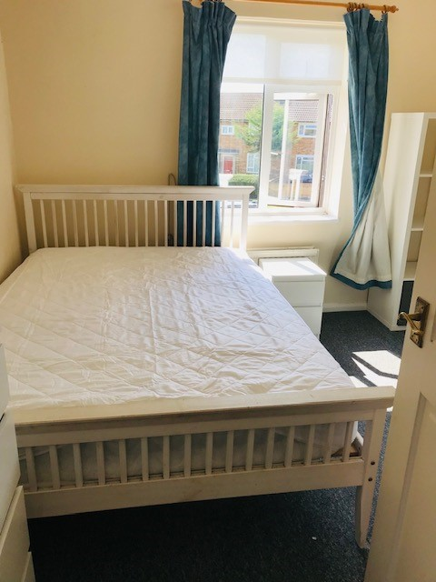

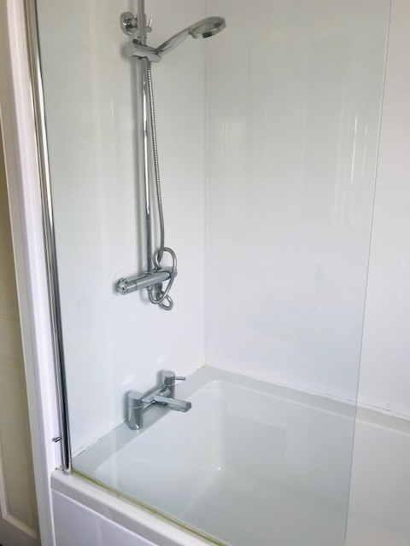

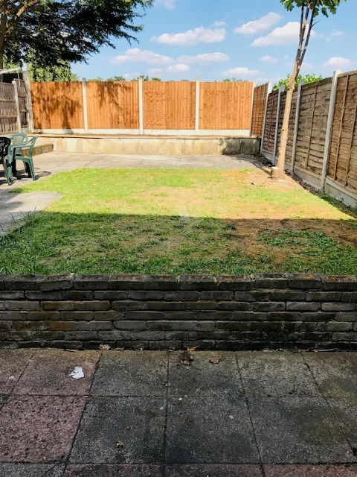

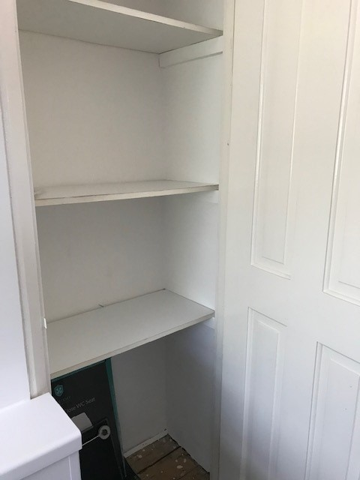

PROPERTY 2

ROOM AVAILABLE, NEAR TO TUBE STATION IN BUCKHURST HILL, 5 MINUTES ON TUBE TRAIN TO EAST 15
The house is a semi-detached family house with a large garden. It is about 3 minutes’ walk from Buckhurst Hill tube and shops, and about 1 minute’s walk away from a large stretch of Epping Forest. Buckhurst Hill is a leafy and pleasant part of Essex.
The room is self-contained at the front of the house. It has an ensuite bathroom, mini fridge and kettle. It is equipped with bed, wardrobe, chest of drawers, bookshelf, desk, chair and easy chair. There is also a large cabinet in the bathroom. There is a spare bed for occasional guests. The room has an extra space at high level (there is a high ceiling), which can be used for storage. We can provide towels and bedding if wished. There is wifi.
In the kitchen, there is a dishwasher, microwave, cooker and washing machine. There is space in the garden shed for a bicycle.
The room is available to a postgraduate or mature student who prefers to be independent rather than in a shared house. We are friendly but not intrusive – the student would be free to come and go as they wish. In case of allergies, please note that we have a cat.
The room is available from September, but this could possibly be earlier by arrangement.
The fee for the room is £585 per month, inclusive of all bills and wifi. Deposit of £350.
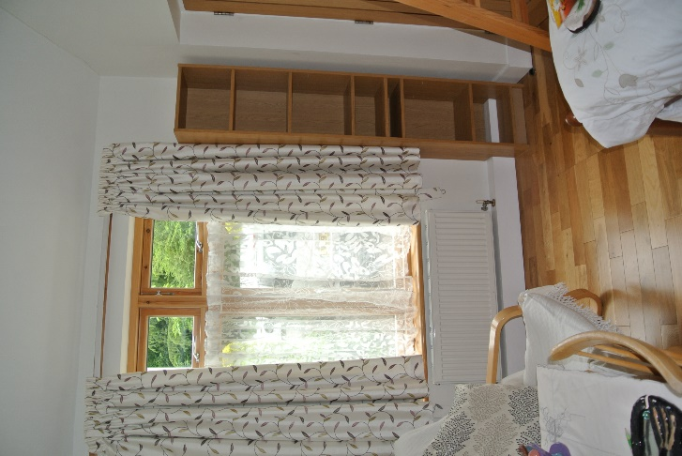
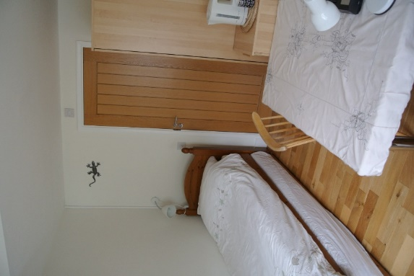
For further details or to arrange a viewing (virtual or in person), call 07960 793717 or email wendyblakeranken@outlook.com.
