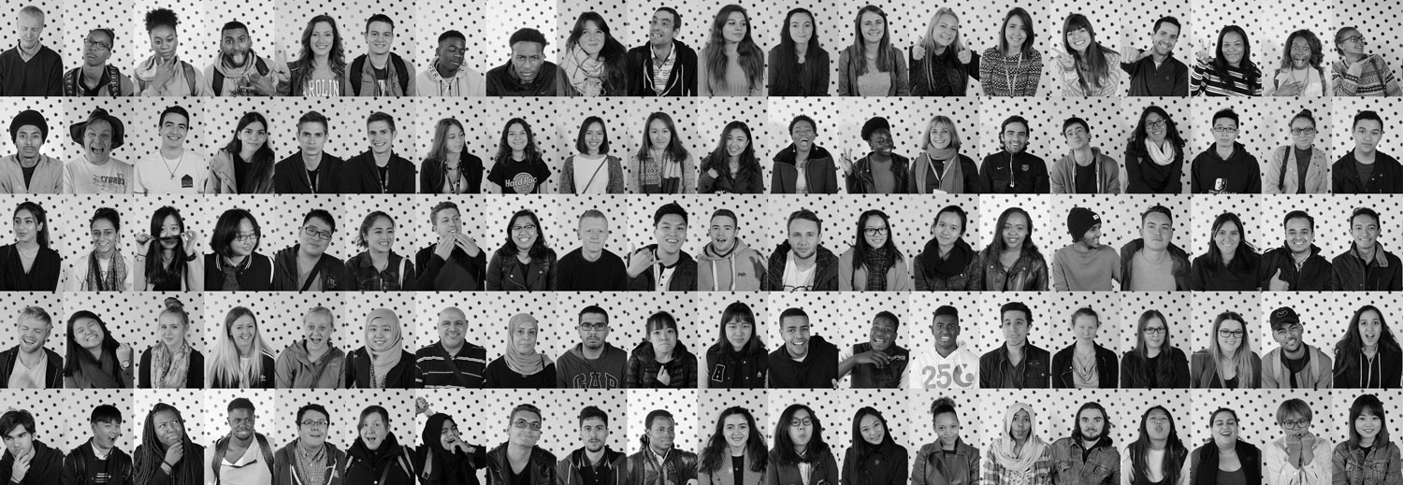

UNIVERSITY OF ESSEX STUDENTS* UNION
STUDENT ACTIVITIES
POLICIES & PROCEDURES

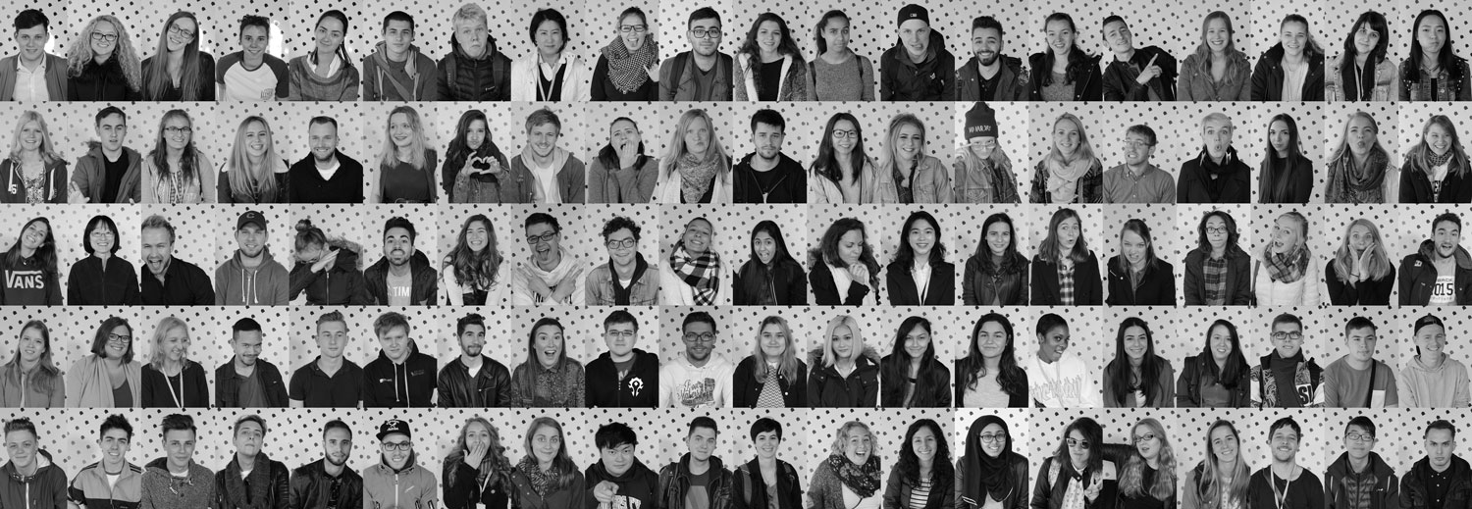

Version: 1
Approved by: Rachel Waddon & Dominic King
Date: 31st August 2022
Review date (by): 31st August 2023
Owner: Rachel Waddon & Dominic King
Author: Rachel Waddon

SU STUDENT ACTIVITIES
POLICIES & PROCEDURES
CONTENTS
- Introduction
- Purpose
- Alcohol Policy
- Social Media Charter
- Interpretation
- Revocation
- Confirmation and Agreement of Policies

A: INTRODUCTION
These Policies & Procedures shall apply to all University of Essex Students’ Union recognised Societies and Essex Blades Sports Clubs
B: PURPOSE
The purpose of these policies and procedures is to provide the membership of these organisations with clear guidance on how they conduct their activities.
These policies have been created in accordance with any legal considerations that apply to activities and also to ensure that members participating in Essex Blades Clubs & SU Societies can do so safely.
C: UNIVERSITY OF ESSEX STUDENTS’ UNION CLUBS AND SOCIETIES ALCOHOL POLICY
- Introduction

1.1 The Students’ Union is committed to providing a safe, healthy study and work and leisure environment that fosters and promotes the sensible consumption of alcohol.
1.2 The Students’ Union recognises that the consumption of alcohol is for many students part of the ‘student experience’ and University life.
1.3 The Students’ Union recognises its responsibilities associated with both the selling and provision of alcohol and will exercise its duty of care towards staff, students and others by ensuring that the consumption of alcohol on campus is managed responsibly and complies with the Licensing Act 2005.

- Students’ Union Policy

2.2 The Students’ Union is committed to developing a social culture that promotes the sensible use of alcohol and offers suitable alternatives to those who prefer alcohol-free activities.
2.3 The Students’ Union does not condone the misuse or abuse of alcohol and is committed to reducing the risks associated with alcohol use within its community. Whenever it is appropriate the University will take disciplinary action in response to unacceptable behaviour associated with the misuse or abuse of alcohol.
2.4 Where a student has engaged in aggressive, abusive or other anti-social behaviour in part as a result of the use of alcohol, this will in no way excuse the behaviour or mitigate the penalties imposed in so far as the application of the Students’ Union Disciplinary Committee.
2.5 The Students’ Union will ensure that bars located on the campus will be managed under license and conform to legal requirements.
2.6 The Students’ Union will always encourage our customers to drink responsibly.
2.7 The Students’ Union will always make sure that where alcohol is being served free water and soft drinks must be available to all customers in all bars.
2.8 The venues will provide plastic glasses to be used at any event and time where glass is considered a risk and for outdoor use.

- Clubs and Societies Policy

3.1 It should be remembered that groups of the Students’ Union must at all times act to uphold the reputation of the Students’ Union whether on campus or an alternative venue.
3.2 Where an event is being held on University owned premises, the Students’ Union Clubs and Societies should abide by the Students’ Union Alcohol Policy and the University of Essex Alcohol and Drug Policy.
3.3 Students who are very drunk must not be encouraged to drink more alcohol.
3.4 Where a student needs to go to hospital due to alcohol consumption, they must be accompanied by a responsible person. Any hospital visits of this nature must be reported to the Students’ Union Deputy Director of Student Activities and Support (fjharvey@essex.ac.uk) within 24 hours of admittance.
3.5 Clubs and Societies must not highlight drugs or alcohol as the main reason for attending an event. Publicity should indicate that there will be non-alcoholic drinks available at the event.
3.6 All promotional activity will ensure that we market and promote events containing alcohol responsibly and that there will be no active promotion of drinking games.

- Minibus Policy

4.1 Any student who is driving members of a Students’ Union Club/Society as part of an event must not consume any alcohol prior to driving. Blood alcohol levels should be zero during all driving activities; alcohol should not be consumed in the eight hour period prior to driving.
4.2 When travelling on provided transport (i.e. Minibuses, coaches or cars), no alcohol is permitted to be carried onto/consumed on board at any time. Failure to comply with this rule invalidates our insurance and is against the law above all.
4.3 The designated driver of the vehicle has the authority to refuse entry onto the vehicle or refuse to drive, if any member’s behaviour is deemed unacceptable. Disciplinary action will be taken against any student who is reported by the designated driver.

- Initiations & Socials

An initiation and/or Mothers and Daughters/Fathers and Sons is an event in which members (often new members) of a club/society are expected to perform any activity as a means of gaining credibility, status or entry into that club/society. The peer pressure is normally (though not explicitly) exerted on first year members or members new to that particular club/society and may involve the consumption of alcohol, eating concoctions of various food stuffs, nudity and any behaviour that may be deemed humiliating.
The following guidelines are in place to protect the students:
  - Drinking/Initiations are not condoned by the Students’ Union. If it is discovered that such an event has taken place, the club/society will be faced with appropriate disciplinary action which may include; removal of executive members from position or dissolution of club/society. Please note that this is not an exhaustive list of repercussions.
  - Clubs/Societies should be a welcoming environment and any reports of hazing will be investigated.
  - Any members of Clubs/Societies will not apply what may be perceived as peer pressure upon individuals in any social situation, this extends to any ‘tradition’ within the club/society.
  - The committee of each club/society are responsible for the welfare of all club/society members at all club/society organised event. The committee must take the necessary measures to ensure that an adequate level of safety is maintained at all times.
  - Water must be made available at all socials.
  - A non-alcoholic alternative must be available at all events where alcohol is served.
- Bar/Pub Crawls

The University of Essex Students’ Union does not support organised bar crawls– whether they take place on the high street or in Student Union venues. Bar/Pub Crawls contribute to the negative image of the student binge drinker, can worsen social tensions in the local community and can be dangerous to Students’ health and well-being.
The following guidelines are in place to protect the students:
6.1 Students should not be expected or forced to consume alcohol at each venue.
6.2 Students should remember that they are representatives of the University when in the local community and therefore act accordingly.
6.3 The committees are responsible for the actions of their members whilst on the bar crawl therefore should make sure that their actions are kept under control.

7. Breaches of Code of Conduct

Breaches in this policy may result in a disciplinary hearing, carried out by the University of Essex Students’ Union Disciplinary Committee. The Disciplinary Committee will be made up of staff and Officers from the Students’ Union and the University where applicable.
In less severe cases the Student Activities Sabbatical Officer and Student Activities Manager(s) will determine the disciplinary action to be taken.
Any breach of the procedure will result in one or more of the following:
7.1 20% fine of the Club/Society account
7.2 Removal of Individuals from BUCS Competition
7.3 Removal of teams from BUCS Competition
7.4 Individual Expulsion from all SU Societies/Essex Blades Club
7.5 Club/Society Dissolution
If any incidents occur at the end of a season, the sanctions may be levied for the following year.

D. SOCIAL MEDIA CHARTER

To ensure that all content on Essex Blades Sports Club and SU Societies pages is appropriate, we have put together an Essex Blades & Societies Social Media Charter including a list of ‘Do’s and Do Not’s’ to help our clubs and societies follow good practice.
Sports and societies are for all – and our clubs and societies should act as ambassadors for this message by making sure they are inclusive and welcoming of all new members.
Social Media pages will be one of the main ways that clubs and societies are promoted to current and potential new members. It is also the main way to promote activity to other members of the University community, sponsors, family and friends, National Governing Bodies and other partners.
With all the above considered, it is therefore essential that all Essex Blades Sports Club and Society social media pages are active, but that all posts are appropriate.

DO’s | DO NOT’s
- Support other clubs, societies & individuals - share their success.  - Use appropriate images/videos and language.  - Engage with the wider community (e.g. local clubs, campaigns).  - Tagging/linking Essex Blades or Societies, use hashtags.  - Post videos, interesting content.  - Display sportsmanship and respect at all times. Be a positive competitor.  - Promote all training sessions/matches/events – make accessible to all.  - Update all scores & results - Celebrate all teams within your Sports Club, whether they win or lose.  - Engage positively with other Essex Blades/Society accounts.  - Protect privacy – check permission before posting photos.  - High quality content – including spelling, grammar & images.  - Promote inclusiveness and participation (not just competition).  - Post regularly. Active pages are more appealing!  - Post about socials e.g. end of season meals/celebrations. However, do not post pictures of excessive alcohol.  - Be enthusiastic and welcoming to all!  - Use wider campaigns to promote your activity e.g. This Girl Can – you may also get extra publicity and other benefits from it. | - Swearing or abusive language.  - Discrimination.  - Negative comments about rivals or members of your club/society.  - Promotion of alcohol/drugs.  - Racism/cultural appropriation/sexism.  - Negative comments towards other Sports, Sports Clubs or Societies.  - Post antagonistic opinions.  - Put down other Universities or their competitors/members.  - Post about initiations – they are banned!  - Post photos of the same friends within club/society – always post whole club/society photos to avoid cliquey atmosphere.  - Only post success of elite squad or first teams – clubs are made up of lots of teams and members.  - Do not like/share/retweet any content that is offensive or breaches any other points of this charter on Essex Blades Sports Club/Society accounts.  - Do not use Essex Blades/Society accounts to follow inappropriate accounts.  - Don’t have more than three people working on content for your accounts – this will lose style and consistency.

In addition to these do’s and don’ts, all those with access to posting on social media on behalf of the club/society must read, understand and agree to the following;
- Any photos or video content posted on social media must either be
  - owned by the person posting; or
  - written permission has been obtained to post the image/video belonging to another; or
  - the image is free to use and appropriate attributions have been made if required; or
  - the appropriate license to use a photo/video has been obtained.
Websites such as pixabay and pexels are recommended – please check the attributions requirement and permissions.

- Any posts shared from another account are not at risk of libel or defamation
  - Check the authenticity of posts on social media
  - If you post or share content about someone/a company you open yourself up to a defamation claim which you may be personally responsible to pay for. This includes retweeting or sharing other accounts posts regardless of who originally wrote the post.
  - If you are unsure whether you can post something on social media, please email sumediapanel@essex.ac.uk for clarification.

E. INTERPRETATION
Reference to any bodies and persons in these Policies & Procedures includes any duly appointed or elected successors.
Any matters not specifically covered by these Policies & Procedures shall be referred to the SU Student Activities Manager(s) who shall make a ruling whose majority decision shall be final.

F. REVOCATION
All previous versions of policies and procedures covered in this document. are hereby expressly revoked.

G. CONFIRMATION & AGREEMENT OF POLICIES
To be signed by the society/club President; Vice-President/Secretary; Treasurer; Welfare Officer and any members who will lead on a social event or have access to society/club Social Media.
On behalf of the …………………………………… Club/Society, I have read and agree to the policies above. If I did not understand any content within these policies & procedures, I ask for clarification from a member of the SU Student Activities Team.
I understand that content posted in breach of the Essex Blades & Societies Social Media Charter may be deemed as bringing the Essex Blades, Societies, Students’ Union and University of Essex into disrepute, and may lead to disciplinary action taken against my Sports Club/Society.
By signing this, I agree to follow the Do’s and Don’ts listed in this document and will ensure due diligence when posting on my club/society social media.

PRESIDENT
Name: ………………………………………………………….
Signature: ………………………………………………………
Date: …………………………………………………………..

VICE-PRESIDENT
Name: ………………………………………………………….
Signature: ………………………………………………………
Date: …………………………………………………………..

SECRETARY
Name: ………………………………………………………….
Signature: ………………………………………………………
Date: …………………………………………………………..

TREASURER
Name: ………………………………………………………….
Signature: ………………………………………………………
Date: …………………………………………………………..

WELFARE OFFICER
Name: ………………………………………………………….
Signature: ………………………………………………………
Date: …………………………………………………………..

Position ………………………………………………………….
Name: ………………………………………………………….
Signature: ………………………………………………………
Date: …………………………………………………………..

Position ………………………………………………………….
Name: ………………………………………………………….
Signature: ………………………………………………………
Date: …………………………………………………………..

Position ………………………………………………………….
Name: ………………………………………………………….
Signature: ………………………………………………………
Date: …………………………………………………………..

Position ………………………………………………………….
Name: ………………………………………………………….
Signature: ………………………………………………………
Date: …………………………………………………………..

