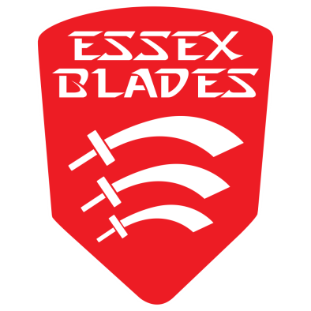
2023-24 ESSEX BLADES & SOCIETIES SOCIAL MEDIA CHARTER

To ensure that all content on Essex Blades Sports Club and SU Societies pages is appropriate, we have put together an Essex Blades & Societies Social Media Charter including a list of ‘Do’s and Do Not’s’ to help our clubs and societies follow good practice.

Sports and societies are for all – and our clubs and societies should act as ambassadors for this message by making sure they are inclusive and welcoming of all new members.

Social Media pages will be one of the main ways that clubs and societies are promoted to current and potential new members. It is also the main way to promote activity to other members of the University community, sponsors, family and friends, National Governing Bodies and other partners.

With all the above considered, it is therefore essential that all Essex Blades Sports Club and Society social media pages are active, but that all posts are appropriate.

Terms of agreement

By signing this Essex Blades & Societies Social Media Charter, I _________________ representing the _________________ Club/Society agree to follow the Do’s and Do Not’s listed in this document.

I understand that content posted in breach of the Essex Blades & Societies Social Media Charter may be deemed as bringing the Essex Blades, Societies, Students’ Union and University of Essex into disrepute, and may lead to disciplinary action taken against my Sports Club/Society and individuals responsible.

Date: __________________________

Signed by Sports Club/Society Official: __________________________

DO’s | DO NOT’s
- Support other clubs, societies & individuals - share their success.  - Use appropriate images/videos and language.  - Engage with the wider community (e.g. local clubs, campaigns).  - Tagging/linking Essex Blades or Societies, use hashtags.  - Post videos, interesting content.  - Display sportsmanship and respect at all times. Be a positive competitor.  - Promote all training sessions/matches/events – make accessible to all.  - Update all scores & results - Celebrate all teams within your Sports Club, whether they win or lose.  - Engage positively with other Essex Blades/Society accounts.  - Protect privacy – check permission before posting photos.  - High quality content – including spelling, grammar & images.  - Promote inclusiveness and participation (not just competition).  - Post regularly. Active pages are more appealing!  - Post about socials e.g. end of season meals/celebrations. However, do not post pictures of excessive alcohol.  - Be enthusiastic and welcoming to all!  - Use wider campaigns to promote your activity e.g. This Girl Can – you may also get extra publicity and other benefits from it. | - Swearing or abusive language.  - Discrimination.  - Negative comments about rivals or members of your club/society.  - Promotion of alcohol/drugs.  - Racism/cultural appropriation/sexism.  - Negative comments towards other Sports, Sports Clubs or Societies.  - Post antagonistic opinions.  - Put down other Universities or their competitors/members.  - Post about initiations – they are banned!  - Post photos of the same friends within club/society – always post whole club/society photos to avoid cliquey atmosphere.  - Only post success of elite squad or first teams – clubs are made up of lots of teams and members.  - Do not like/share/retweet any content that is offensive or breaches any other points of this charter on Essex Blades Sports Club/Society accounts.  - Do not use Essex Blades/Society accounts to follow inappropriate accounts.  - Don’t have more than three people working on content for your accounts – this will lose style and consistency.

