How to Add an Event to Your Webpage

- From your society’s webpage, click the ‘page admin’ drop-down menu on the top banner and then select ‘[your society] admin tools’.
- Click ‘Events’ (calendar icon).
- Click ‘Add new event’.
- Fill in the details as required (see screenshots below) and click save.
- If your event needs tickets, please email susocs@essex.ac.uk or blades@essex.ac.uk with this info: the link to your event, all the categories of tickets you need (such as ‘members’ and ‘non-members’), the maximum number of tickets required per category, and the price of tickets inclusive of VAT per category. We’ll set them up for you.
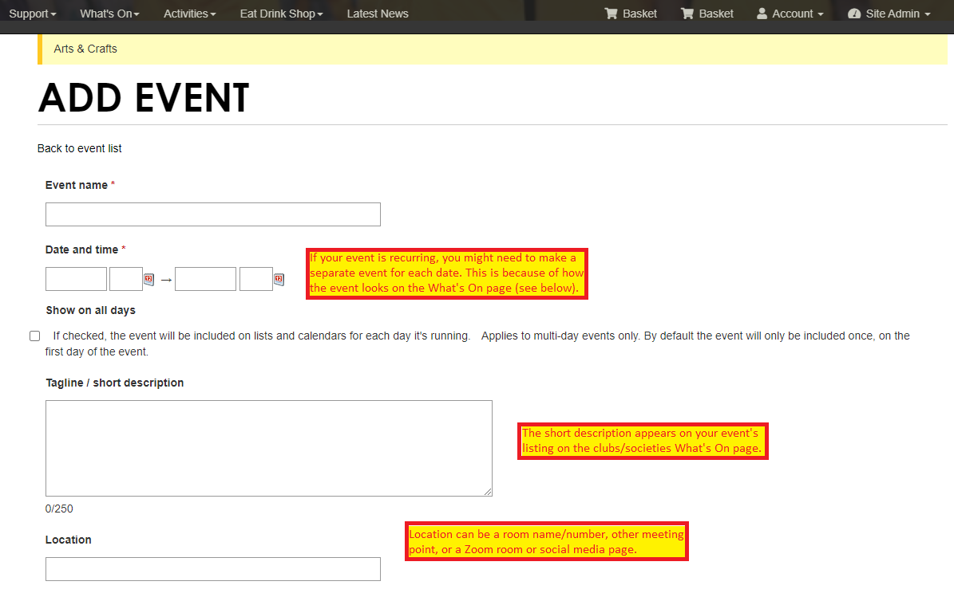
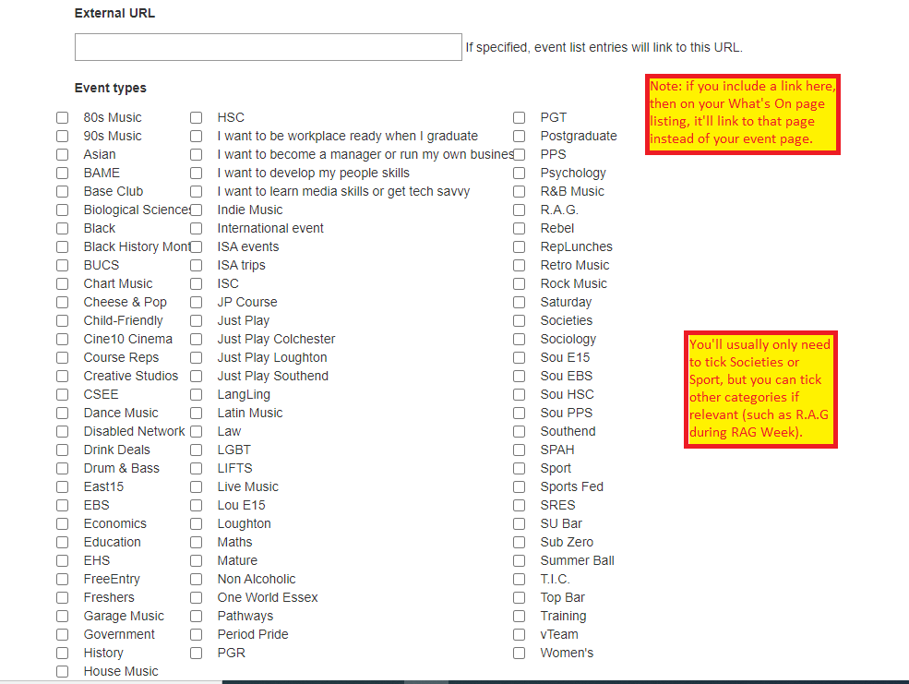
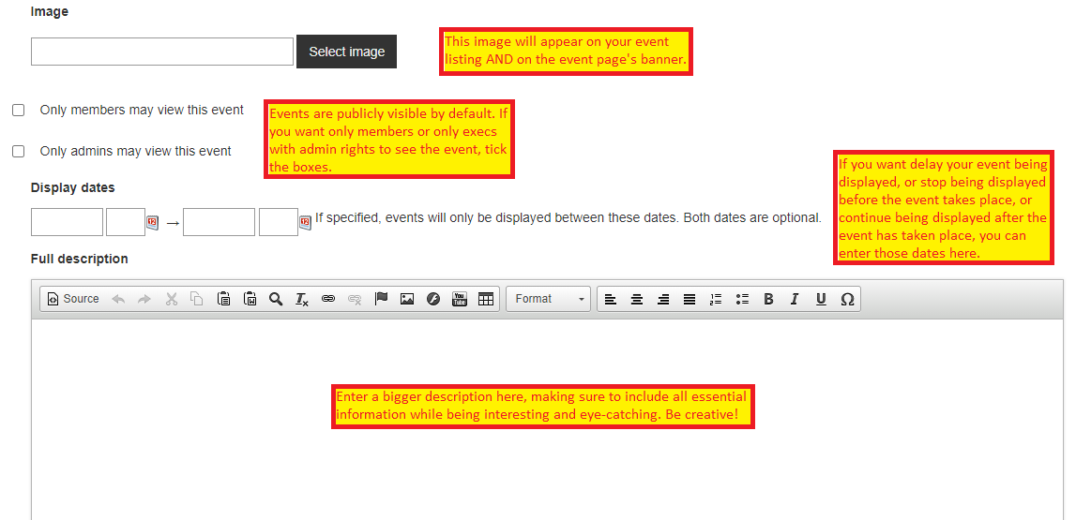

This is how event listings look on the Societies and Clubs What’s On page:
Note that this yellow date box cannot be moved further left. This means that if you have a recurring event across months displayed as, for example, ’16th September – 16th October’, then this will go off the right side and not be visible. The easiest solution is to create a new event for each day.
Recurring events within the same month don’t have this problem, and will be displayed as ‘16th-17th September’.

