HOW TO MAKE AN EXPENSE CLAIM THROUGH EXPENSE IN.

Expense in is the software system we use in order to process all student expenses. In order to be eligible to create an Expense in account you must be a current University of Essex student, and you must use your @essex email. In order to claim back any funds, you also will need to be a valid paid member of the relevant sports club.
Firstly, to make any expense claims you will need an account for the expense in system.
In order to create an account, you will need to follow the steps 1-4 below. If you already have an account, you can move on to step 4.

HOW TO CREATE AN EXPENSE IN ACCOUNT
- Go to Sports Toolkit and go to FINANCE & EXPENSES
- Click “Register for an expense account” if this is your first time claiming an expense and you haven’t registered yet.

- You will receive an email from the University of Essex Students’ Union Expense Team (suexpenses@essex.ac.uk). Please note this is not an automatic process and will take within 2-4 working days. (Example of email below). Please do not submit mulitple registration forms.
- Click “Sign in” from the email or “Log in to claim an expense” on Sports Toolkit if you already have login details.
HOW TO CLAIM BACK AN EXPENSE
- Sign in and go to new expense for claiming an expense
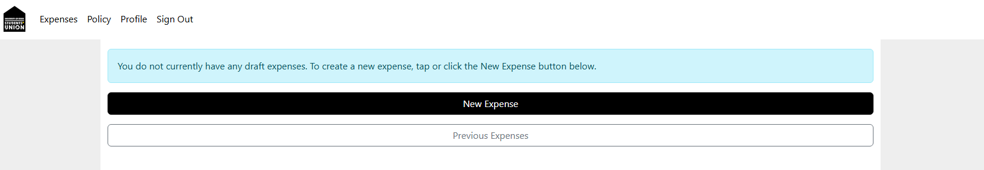

- PURCHASE
- Attach your receipts or other proof of purchase. PLEASE NOTE YOUR EXPENSE WILL BE REJECTED IF THERE IS NO RECEIPT ATTACHED.
- Enter the date of purchase (must match the date on receipts).
- Complete the remaining questions, then click “create expense”

- MILEAGE
- Before submitting your first claim, ensure you have emailed a digital copy of the front and back of your driving licence and insurance to blades@essex.ac.uk. Your claim will be rejected if you have not done this.
- Attach evidence of milage.
- Enter the date of purchase (must match the date on receipts).
- Complete the remaining questions, then click “create expense”

Claiming on behalf of others is NOT ALLOWED! Your claim must be for your own expenditure only.
Please also note that any claims from students without a valid membership to the relevant sports club will be rejected.

Once the expense is created, it must be approved by an admin. After approval, the SU Expenses Team will process your claim. This will take up to 7 working days, with payments always being made for Fridays. It is recommended that you talk to your treasurer about your expense, to ensure it is signed as quickly as possible.

HOW TO CHECK YOUR EXPENSE PROGRESS
- Sign in to your account and click on “Previous Expenses”
- You will see a list of all the expenses you have submitted.
Processing > The expense is waiting to be approved.
Processed> The expense is ready to be paid out, or has already been completed.

ANY QUESTIONS
Please email suexpenses@essex.ac.uk

