University of Essex Students Union
CONFIDENTIAL
Health and Safety Incident Report Form

This form must be completed for any health and safety incident involving University of Essex Students Union staff.
It should be used to report all first aid incidents; work or premises related accidents and ill health.
Please complete the form providing factual and accurate information only, then forward it confidentially to the Facilities, Health and Safety Manager or a member of SUPED within 24 hours of the incident. Serious incidents must be reported immediately.
The form should be completed by the affected / injured person, their representative or a witness to the incident. If a First Aider attended, they should complete the First Aid details. If you need more space continue on a separate sheet, which should be attached to the form.
Please do not type in the shaded areas.

About the Incident
Name of person reporting incident:
Department: |  |  |  |  |  |  |  |  |  |  |  |  |  |  |  | Contact details: (e-mail / login):
Date Incident reported: |  |  |  |  |  |  |  |  |  |  |  |  |  |  |  |  |  |  |  |  |  |  |  | Time reported: |  |  |  |  |  |  |  |  |  | am / pm
Date of incident: |  |  |  |  |  |  |  |  |  |  |  |  |  |  |  |  |  |  |  |  |  |  |  | Time of Incident: |  |  |  |  |  |  |  |  |  | am / pm
Precise Location:
What was being done at the time of the incident:
What happened: Continue on a separate sheet if necessary. Include anything that may have contributed to the incident (e.g. icy conditions).
Nature of harm / ill health / damage:
About the person affected
Name in full:
Address
Home / Student accommodation
Contact details: |  |  |  |  | e-mail: |  |  |  |  |  |  |  |  |  |  |  |  |  |  |  |  | Telephone:
Department: |  |  |  |  |  |  |  |  |  |  |  |  |  |  |  |  |  |  |  |  |  | Position (employee):
Status: highlight using:  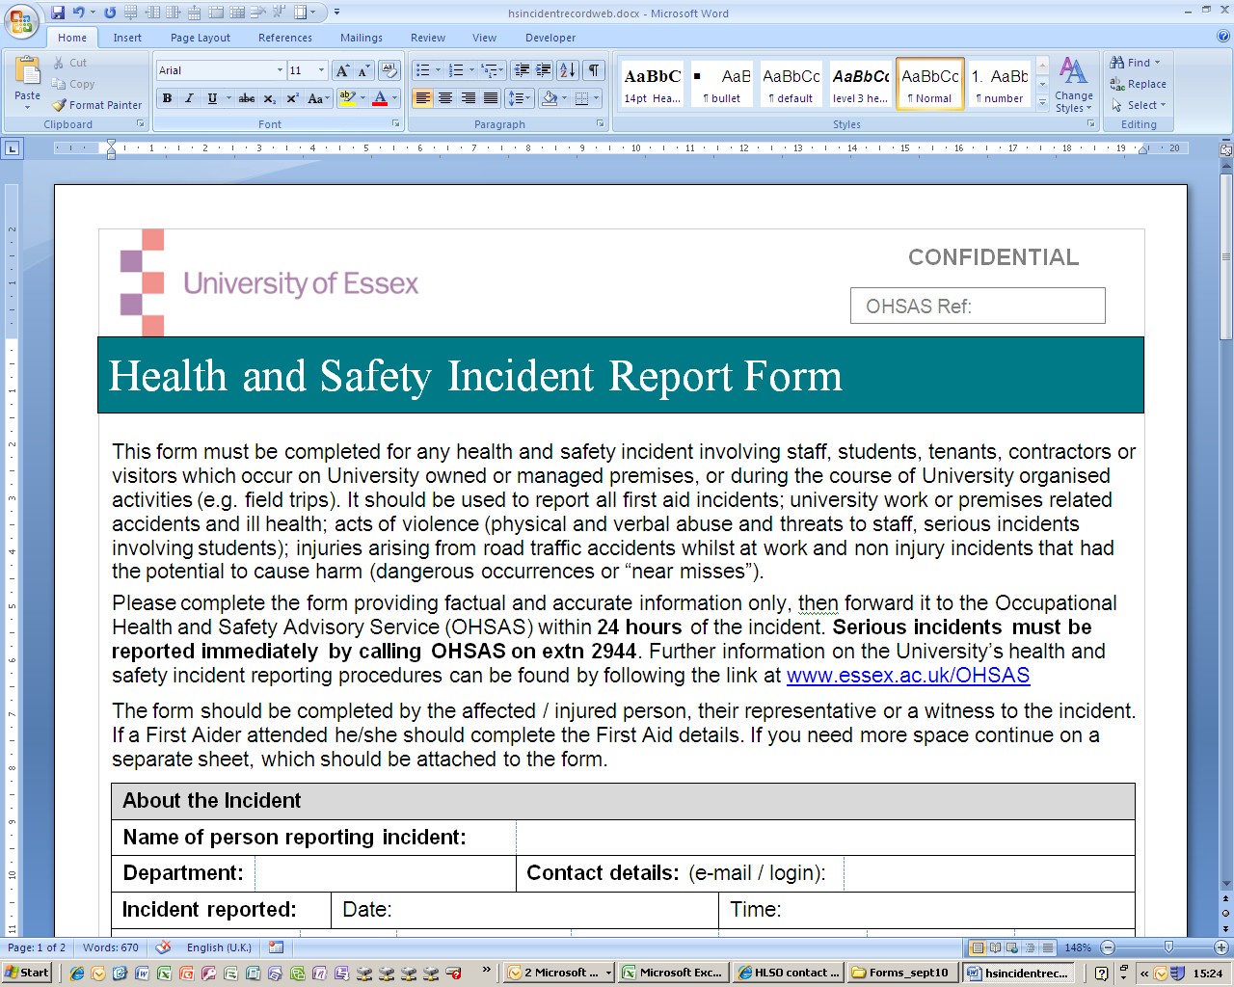 |  |  |  |  |  | Employee |  |  |  |  |  | Student Staff |  |  |  |  | Visitor |  |  |  |  |  | Contractor |  |  |  |  |  | Other (specify):
If visitor: SU contact name:
If contractor: Employer’s name:
If under 16: Name of adult responsible for their supervision:
Signature of injured person (or the responsible adult if under 16):
Witness details: Give name and contact details of any witnesses below:
Name(s): |  |  |  |  |  |  |  |  |  |  |  |  |  |  |  |  |  |  |  | Contact details:
First Aid details (If a First Aider attended he/she should complete this section)
First aid provided: |  |  |  |  |  |  | Yes / No / NA |  |  |  |  |  |  |  |  |  |  | Time of attendance:
If Yes give details,
If No give reason:
Name of First Aider: |  |  |  |  |  |  |  |  |  |  |  |  |  |  |  |  |  |  |  |  |  |  |  |  | Signature:
Post incident action
Action taken to make the situation/environment safe:

What happened to the injured person afterwards: Highlight using appropriate response below:
Taken directly to hospital |  |  |  |  |  |  | Went home |  |  |  |  |  |  |  |  |  | Returned to work/activity |  |  |  |  |  |  |  |  |  | Other: Specify:
If you know the person, responsible for the activity / area where the incident occurred please give their details below:
Name: |  |  |  |  |  |  |  |  |  |  |  |  | Designation: |  |  |  |  |  |  |  |  |  |  |  |  |  |  |  |  | Contact:  e-mail or extn

_______________________________________________________________________________________________
This section is for FHS use.
FHSM ACTION | Received by  FHSM (date / initial) |  |  |  |  |  |  |  |  | Reviewed by lead adviser (date / initial)
RIDDOR reportable? | Yes / No |  |  | RIDDOR ref: |  |  |  |  |  |  | Date:
Type of incident: | Minor |  | First Aid |  |  |  |  |  | Lost Time |  |  |  | RIDDOR
Investigated by: | FHSM Department* Not required
*Copy of incident report passed to: |  |  |  |  |  |  |  |  |  |  | Date:
Report passed to PED? | Yes / No | Date:
Date investigation report returned: |  |  |  |  |  |  |  |  |  | Witness statements / photos / RIDDOR attached? |  | Yes / No
Follow up action:

